**Creation of Builds for CI CD using Jenkins**

**Prerequisites:**

1. Download and Install Java (jdk-17_windows-x64_bin) and configure it (set the environment variables in the system)
2. Download Jenkins Stable LTS i.e. Jenkins. War file from official website Jenkins.io
3. Install Jenkins and update the default plugins during the installation.
4. Change the default password and set the new one.
5. Navigate to URl <http://localhost:8080/> (By default Jenkin takes 8080 port)

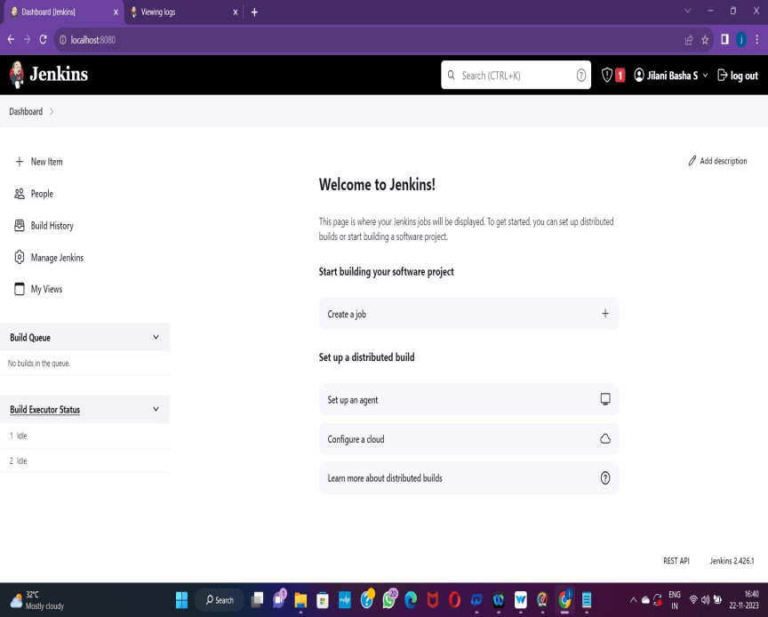



**Open Jenkins and login with username and password. This is the home page of Jenkins, Select new item.**

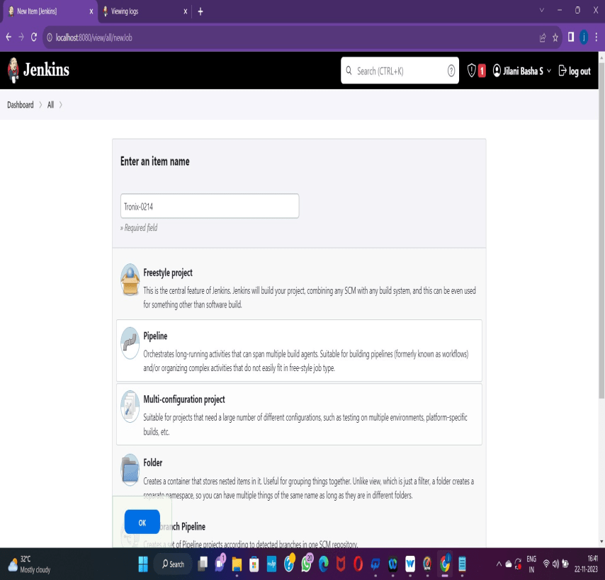



**Enter name and select pipeline and click on Ok**

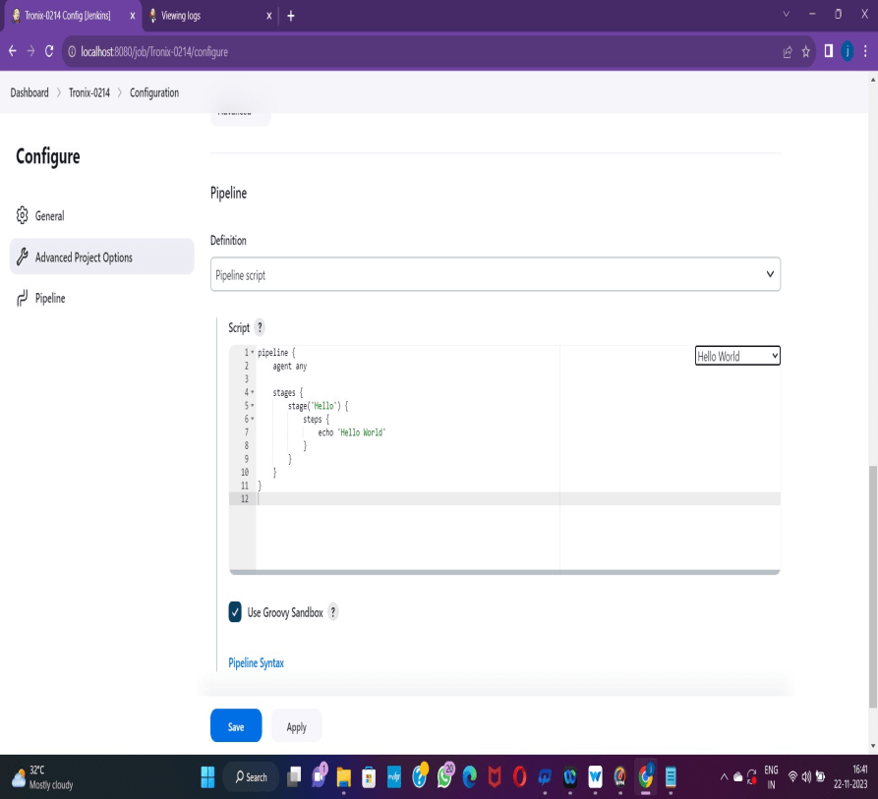



**At first we are selecting simple pipe line of hello world.Then click on apply and save.**

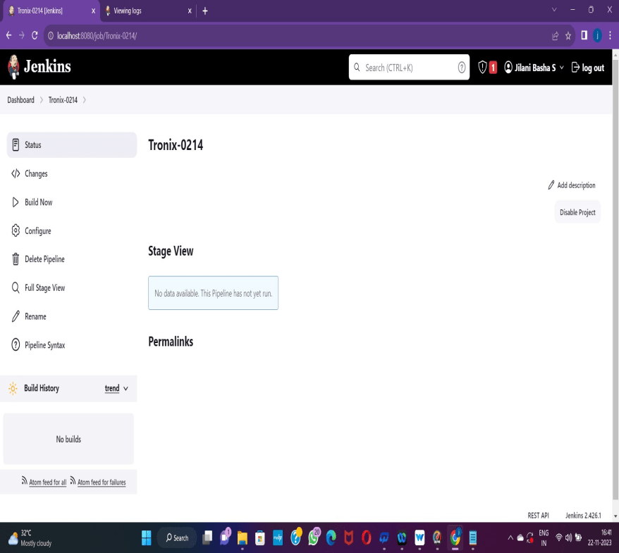



**After clicking on save.You will redirected to this page. Click on Build Now.**

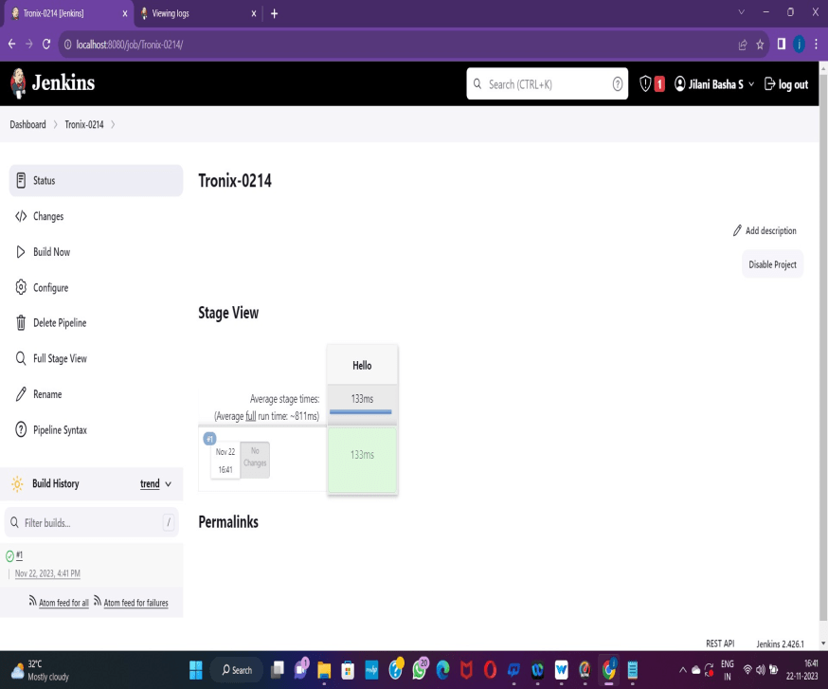



**You can see Build is success.**

**Now, let’s try by changing the code.**

**When we want to change the code and have to build a new one then click on configure.**

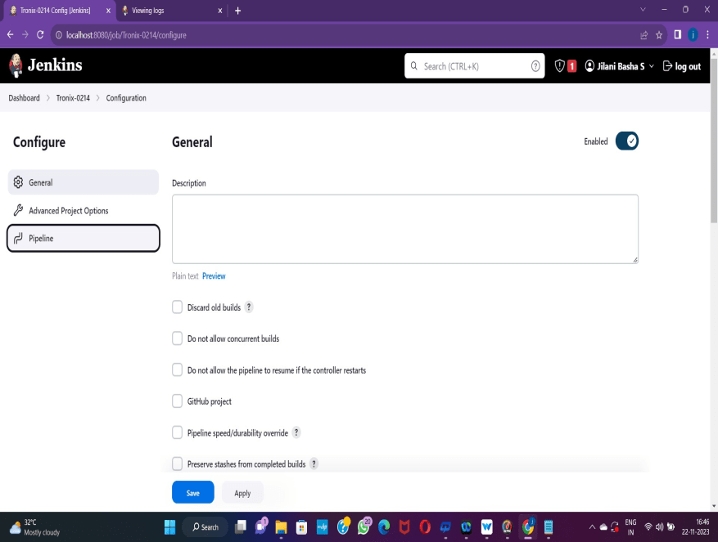



**You will be redirected to this page. Click on pipeline.**

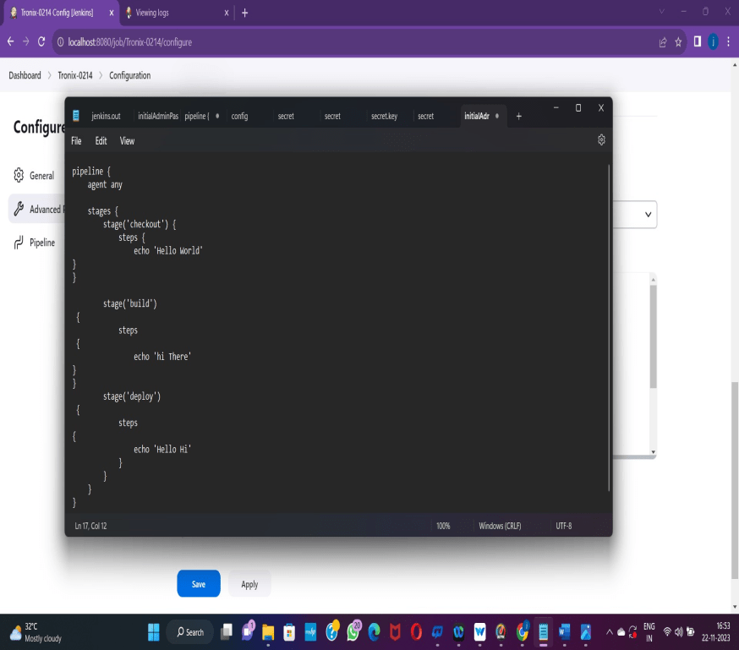

**We have written this code as stages, In stage 1 we wrote Checkout and at stage 2 build and stage 3 deploy . copy the code**

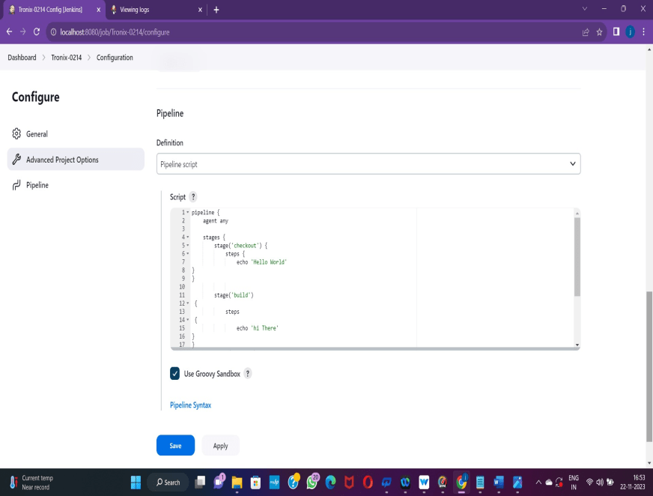



**Paste the copied code here and click on apply and save.**

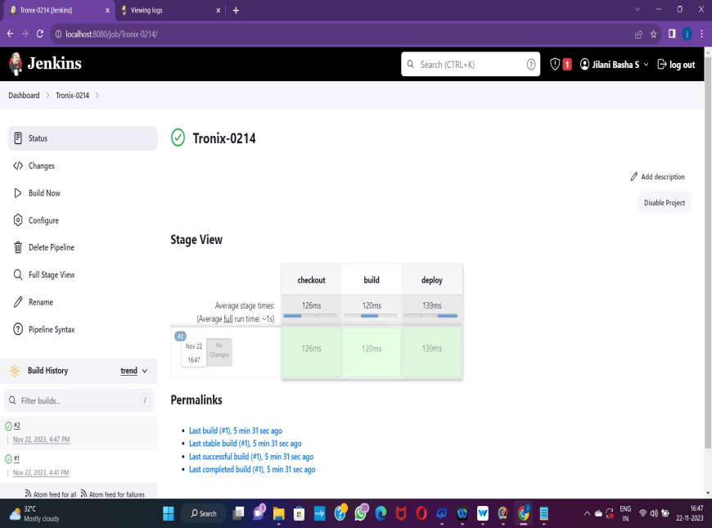



**Click on Build Now, Then The output looks like as above. You can see the stages Checkout, Build and deploy has been successful**

**Now click on #2 .**

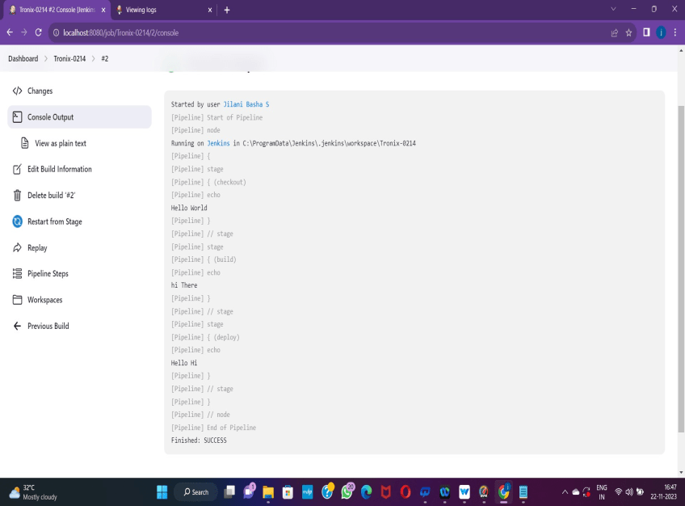



**Here you can see the console output by clicking on console output. Here it is success it means our build is success.**

**You can delete the build if you find any errors only the build which you select will be deleted previous builds will be there.( e.g., Here in our case if we find error in build 2 we can delete the build 2 and move to build1).**

**We can see the previous build by clicking on Previous Build.**